## SQL FUNDAMENTALS

## BETWEEN OPERATOR

### Introduction

The BETWEEN operator is used for comparison in WHERE clauses. It's a comparison operator. You can use it to test if a value is in a range of values. If the value is in the specified range, the query returns all records fallen within that range.

WHERE test_expression BETWEEN low_expression AND high_expression

Note that the BETWEEN operator is inclusive. The above syntax can be written as follows:

WHERE test_expression >= low_expression AND test_expression <= high_expression

**☝ Important:** The **BETWEEN** operator is inclusive. To specify an exclusive range, use the greater than (>) and less than operators (<).

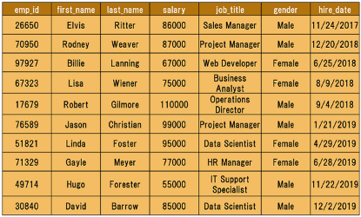

If we need to find the names of the employees with salary amounts between $80,000 and $90,000, we can use the BETWEEN comparison operator to write:

query :

SELECT *

FROM employees

WHERE salary BETWEEN 80000 AND 90000;

Here is the output:

output :

emp_id first_name last_name salary job_title gender hire_date

---------- ---------- ---------- ---------- ------------- ----------

    ----------

26650 Elvis Ritter 86000 Sales Manager Male 2017-11

    -24

30840 David Barrow 85000 Data Scientis Male 2019-12

    -02

70950 Rodney Weaver 87000 Project Manag Male 2018-12

    -20

You could also write the above query as follows:

SELECT *

FROM employees

WHERE salary >= 80000 AND salary <= 90000;

They both return the same result table.

### NOT BETWEEN

We can use NOT BETWEEN to negate the result of the BETWEEN operator. The following is the syntax:

WHERE test_expression NOT BETWEEN low_expression AND high_expression

For instance, you need to find the employees whose salary is not between $80,000 and $90,000. Here is the query:  
  
query :

SELECT *

FROM employees

WHERE salary NOT BETWEEN 80000 AND 90000;

output :

emp_id first_name last_name salary job_title gender

    hire_date

---------- ---------- ---------- ---------- ------------------- ----------

    ----------

17679 Robert Gilmore 110000 Operations Director Male

    2018-09-04

49714 Hugo Forester 55000 IT Support Speciali Male

    2019-11-22

51821 Linda Foster 95000 Data Scientist Female

    2019-04-29

67323 Lisa Wiener 75000 Business Analyst Female

    2018-08-09

71329 Gayle Meyer 77000 HR Manager Female

    2019-06-28

76589 Jason Christian 99000 Project Manager Male

    2019-01-21

97927 Billie Lanning 67000 Web Developer Female

    2018-06-25

There are seven employees whose salary is not between $80,000 and $90,000.

**🛈**We could write this query as follows:

SELECT *

FROM employees

WHERE salary < 80000 OR salary > 90000;

Think about why both queries yield the same result.

### BETWEEN with Date Example

It's also possible to use the BETWEEN operator with dates.

Assume that we try to find employees who have joined the company from June 1, 2018 to March 31, 2019. We also want to sort by hire date in ascending order.

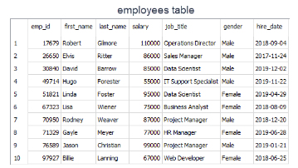

Let's write the query.

**☝ Important:** Please enclose your date values with single quote (') and use YYYY-MM-DD date format in your query.

query :

SELECT * FROM employees

WHERE hire_date BETWEEN '2018-06-01' AND '2019-03-31'

ORDER BY hire_date;

output :

emp_id first_name last_name salary job_title gender hire_date

---------- ---------- ---------- ---------- ------------- ----------

    ----------

97927 Billie Lanning 67000 Web Developer Female 2018-06

    -25

67323 Lisa Wiener 75000 Business Anal Female 2018-08

    -09

17679 Robert Gilmore 110000 Operations Di Male 2018-09

    -04

70950 Rodney Weaver 87000 Project Manag Male 2018-12

    -20

76589 Jason Christian 99000 Project Manag Male 2019-01

    -21

There are five employees who have joined the company from June 1, 2018 to March 31, 2019.  
Now, it's time to put your theory into practice. Enjoy your playground. Feel free to write as many queries as you wish.